

SCHOOL OF COMPUTING

Department of Computer Science and Engineering

CERTIFICATE

This is to certify that the Cornerstone project work entitled “STUDENT HOSTEL MANAGEMENT SYSTEM” is submitted by
K DEVI ANUSHA | (25B11CS498)
B ASRITHA | (25B11CS136)
A SATYA | (25B11CS020)
B SRUTHI | (26B21CS103)

in partial fulfillment of the requirements for the award of the B.Tech. degree in Computer Science and Engineering for the academic year 2026-2027.

Project Guide Head of the Department
Mrs. K Vydehi, M.Tech.,(Ph.D), Dr. Phani Sridhar Addepalli, Ph.D,
Assistant Professor, Assistant Professor,
Department of CSE Department of CSE

DECLARATION

We hereby declare that the Cornerstone project entitled “STUDENT HOSTEL MANAGEMENT SYSTEM” is original and is submitted to ADITYA UNIVERSITY, Surampalem, in partial fulfillment of the requirements for the award of the B.Tech. Degree in Computer Science and Engineering. We further declare that this project work has not been submitted, either in full or in part, for the award of any degree in this or any other institution. We also confirm that this work complies with the Institutional Academic Integrity and AI Usage Policy

Place: Surampalem
Date:
By
K DEVI ANUSHA | (25B11CS498)
B ASRITHA | (25B11CS136)
A SATYA | (25B11CS02)
B SRUTHI | (26B21CS103)

ACKNOWLEDGEMENT

It is with immense pleasure that we express our sincere gratitude to our Cornerstone Project Guide, Mrs. K Vydehi, Assistant Professor, who has guided us throughout the project. Her valuable support, encouragement, and guidance have greatly contributed to the successful completion of this work.
We would like to thank our Deputy Heads of the Department, Dr. Chandra Sekhar Kolli, Associate Professor, Dr Hari Jyothula, Associate Professor and Dr Pennada Siva Satya Prasad, Assistant Professor, Department of Computer Science and Engineering, for their support and valuable suggestions.
Our deepest thanks to our Head of the Department Dr. Phani Sridhar Addepalli, Assistant Professor, for his inspiration and for providing all the necessary facilities and resources required for this project.
We also extend our sincere thanks to Dr. M.V. Rajesh, Associate Dean, School of Engineering for their encouragement and support during the course of our project.
We would like to express our sincere gratitude to Dr. G. Suresh, Registrar, Dr. A Ramesh, Pro Vice-Chancellor (Engineering & Sciences), Dr. S. Rama Sree, Pro Vice-Chancellor (Academics), Dr. M.B. Srinivas, Vice-Chancellor, Dr. M. Sreenivasa Reddy, Deputy Pro Chancellor and Management, Aditya University for providing excellent infrastructure and state-of-the-art laboratories.
Finally, we would like to thank the faculty members, lab technicians, non-teaching staff, and our friends who have directly or indirectly supported us in completing this Cornerstone project successfully.

TABLE OF CONTENTS
S. No | Contents | Page No.
1 | Cover Page
2 | Certificate
3 | Acknowledgement
4 | Table of Contents | 1
5 | Abstract | 2
6 | Introduction | 6
7 | System Analysis | 7-8
8 | Database Design | 9
9 | ER Diagram | 10
10 | Relational Schema | 11
11 | Table Design | 12-13
12 | Normalization | 14-15
13 | SQL Implementation | 16-18
14 | SQL Queries & Screenshots | 19-28
15 | Conclusion & Future Enhancements | 29
16 | References | 30

ABSTRACT
The Student Hostel Management System is a database-based software application developed to simplify and efficiently manage the various activities involved in hostel administration. In a traditional hostel management system, important information such as student details, room allocation, fee payments, attendance, complaints, and hostel records is often maintained manually using registers or separate files. This manual approach can result in data duplication, human errors, difficulty in updating records, loss of information, and delays in retrieving required details. To overcome these problems, the proposed Student Hostel Management System provides a centralized and organized platform for storing, managing, and accessing hostel-related information. The system maintains important details of students, hostels, rooms, wardens, room allocations, payments, attendance, and complaints in a structured database. The administrator can add, update, delete, and view student and room information whenever required. The system also helps administrators monitor room availability and manage student room allocations efficiently, ensuring that the available hostel resources are properly utilized. Database management concepts such as primary keys, foreign keys, constraints, relationships, and normalization are used to maintain data consistency, integrity, and accuracy. By storing related information in separate but connected tables, the system reduces redundancy and makes data retrieval easier and more reliable. The system can also provide useful information about student allocations, available rooms, payment records, and other hostel activities whenever required. The main objective of the Student Hostel Management System is to reduce manual work, minimize errors, save time, improve data accuracy, and provide an efficient method for managing hostel operations. It also improves the accessibility of information by allowing authorized users to retrieve required records quickly instead of searching through multiple physical registers. The system can be useful for colleges and educational institutions where a large number of students and hostel facilities need to be managed regularly. In the future, the system can be enhanced with additional features such as online fee payment, automated notifications, visitor management, complaint tracking, attendance monitoring, student login, warden login, room change requests, and report generation. Thus, the Student Hostel Management System provides a simple, organized, and reliable solution for managing hostel information and can significantly improve the overall efficiency of hostel administration.

LIST OF FIGURES
S. No | Figure No | Title of the Figure | Page No
1 | Figure 1 | ER Diagram of Student Hostel Management System Database | 10
2 | Figure 2 | Major Database Entities | 12
3 | Figure 3 | Student Table | 12
4 | Figure 4 | Hostel Table | 12
5 | Figure 5 | Room Table | 12
6 | Figure 6 | Allocation Table | 12
7 | Figure 7 | Payment Table | 13
8 | Figure 8 | Keys and Constraints | 13

LIST OF TABLES
Table No | Table Name | Page No
6.1 | Major Database Entities | 12
6.2 | Student Table | 12
6.3 | Hostel Table | 12
6.4 | Room Table | 12
6.5 | Allocation Table | 12
6.6 | Payment Table | 13
6.7 | Keys and Constraints | 13
6.8 | Sample Data Records | -

ACRONYMS
- DBMS – Database Management System
- ER – Entity Relationship
- SQL – Structured Query Language
- DDL – Data Definition Language
- DML – Data Manipulation Language
- DQL – Data Query Language
- DCL – Data Control Language
- TCL – Transaction Control Language
- PK – Primary Key
- FK – Foreign Key
- 1NF – First Normal Form
- 2NF – Second Normal Form
- 3NF – Third Normal Form

1. INTRODUCTION

1.1 Brief Information about the Project
A Student Hostel Management System is a database application that manages hostel-related information and administrative activities. The project provides a centralized relational database for students, hostels, rooms, room allocations, fees, complaints, and attendance. It is intended to replace manual records and multiple files with a structured database that supports accurate data storage, easy retrieval, efficient room allocation, and effective hostel management.

1.2 Motivation and Contribution of Project
The project is motivated by common problems in hostel management such as manual record keeping, room allocation difficulties, duplicate records, time-consuming searches, and difficulty in tracking fees and complaints. A centralized database provides a systematic approach to storing hostel information and maintaining relationships between students, rooms, allocations, and other hostel activities.
- Centralizing hostel records in one relational database.
- Reducing duplicate and inconsistent information.
- Maintaining data integrity using primary and foreign keys.
- Supporting faster student and room searches.
- Simplifying room allocation and hostel fee management.
- Providing a foundation for student, room, fee, attendance, and complaint management.

1.3 Objectives of the Project
- Develop a centralized hostel database.
- Manage student records.
- Maintain hostel and room details.
- Handle student room allocation.
- Record hostel fee details.
- Manage student complaints.
- Maintain attendance records.
- Reduce duplicate data and update errors.

1.4 Scope of the Project
The scope covers database-oriented management of student hostel information. The core scope includes student, hostel, room, room allocation, fee, attendance, and complaint data. The database can be used as the backend for a hostel administration application and can be extended later with visitor management, online fee payment, notifications, maintenance tracking, and web/mobile interfaces.
2. SYSTEM ANALYSIS

2.1 Existing System
- Manual maintenance of student and hostel records.
- Multiple Excel sheets or disconnected files.
- Duplicate and inconsistent student information.
- Time-consuming room allocation and record searches.
- Difficulty in tracking hostel fees and complaints.
- Difficulty in generating consolidated hostel reports.
- Higher possibility of data-entry and record-management errors.

2.2 Proposed System
The proposed system uses a centralized relational database to manage hostel-related information. It organizes data into related tables and uses primary keys, foreign keys, UNIQUE, NOT NULL, and CHECK constraints to maintain data accuracy and integrity. The system supports student, hostel, room, allocation, fee, attendance, and complaint management.
- Centralized hostel database
- Student management
- Hostel and room management
- Room allocation management
- Fee management
- Attendance management
- Complaint management
- SQL-based reporting
- Referential integrity

2.3 Functional Requirements
Module | Functional Requirement
Student Management | Add, update, search, and display student details.
Hostel Management | Store and maintain hostel information.
Room Allocation | Allocate rooms to students.
Fee Management | Manage fee payments.
Attendance Management | Maintain attendance records.
Complaint Management | Record and track complaints.
Search & Reporting | Retrieve required details using SQL.

Non-Functional Requirements
- Performance – Queries should execute quickly and efficiently.
- Integrity – Invalid and duplicate data should be prevented.
- Security – Student and hostel data should be protected.
- Usability – Forms and reports should be simple and clear.
- Reliability – Data should remain accurate and consistent.
- Scalability – System should support increasing students and rooms.

2.5 Requirements Specification
Category | Suggested Requirement
Hardware | Intel i3 or above; 4 GB RAM minimum; adequate storage; standard display and keyboard/mouse.
Operating System | Windows 10/11 or an equivalent supported platform.
Database | Oracle Database or another relational DBMS used by the implementation.

3. DATABASE DESIGN

3.1 Major Entities
Entity | Description
Student | Stores student details.
Hostel | Stores hostel information.
Room | Stores room details and availability.
Allocation | Records room allocation details.
Payment | Stores payment information.
Warden | Stores warden details.

3.2 ER Model
The ER model represents the major entities and their relationships in the Student Hostel Management System. The diagram shows Student–Hostel, Student–Room, Room–Allocation, Allocation–Payment, and Room–Warden relationships. It also includes entities such as Student, Hostel, Room, Allocation, Payment, Warden, AC Room, and Non-AC Room, with attributes like Student_ID, Student_Name, Room_ID, Allocation_ID, Payment_ID, Warden_ID, Payment_Date, Amount, and Room_Status.

3.3 Relationships
Relationship | Description
Student → Hostel | A hostel can accommodate many students.
Student → Room | A student can be allocated a room.
Room → Allocation | A room can have multiple allocation records.
Allocation → Payment | An allocation can have payment records.
Room → Warden | A warden can manage multiple rooms.
Room → AC Room / Non-AC Room | A room can be classified as AC or Non-AC.

4. ER DIAGRAM
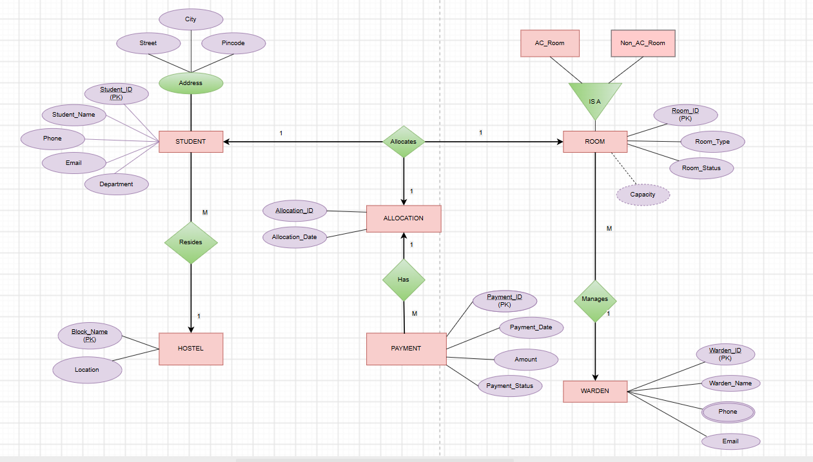

Figure 1: ER Diagram of Student Hostel Management System
The ER diagram represents the major entities, attributes, and relationships in the Student Hostel Management System. It shows entities such as Student, Hostel, Room, Allocation, Payment, and Warden, along with AC Room and Non-AC Room specialization. The diagram also represents the relationships and cardinalities between students, rooms, allocations, payments, hostels, and wardens.

5. RELATIONAL SCHEMA
Relation | Relational Schema
STUDENT | STUDENT(Student_ID, Student_Name, Phone, Email, Department)
HOSTEL | HOSTEL(Hostel_ID, Hostel_Name, Location)
ROOM | ROOM(Room_ID, Hostel_ID, Room_Type, Capacity, Status)
WARDEN | WARDEN(Warden_ID, Warden_Name, Phone, Email)
ALLOCATION | ALLOCATION(Allocation_ID, Student_ID, Room_ID, Allocation_Date)
PAYMENT | PAYMENT(Payment_ID, Allocation_ID, Payment_Date, Amount, Status)

The relational schema follows the structure of the Student Hostel Management System. The Room relation references Hostel; Allocation references Student and Room; Payment references Allocation; and Room is classified into AC Room and Non-AC Room. Warden manages the hostel rooms.

6. TABLE DESIGN

6.1 Major Database Entities
Entity / Table | Description
STUDENT | Stores student details
HOSTEL | Stores hostel details
ROOM | Stores room information
PAYMENT | Stores hostel payment details
ALLOCATION | Stores student room allocation

6.2 Student Table
Attribute | Data Type | Constraint | Description
Student_ID | INT | PK,NOT NULL | Unique student identifier
Student_Name | VARCHAR | NOT NULL | Student name
Roll_Number | VARCHAR | UNIQUE | Institution roll number
Gender | VARCHAR | — | Gender value as required by implementation
DOB | DATE | — | Date of birth
Age | INT | — | Age, if maintained
Email | VARCHAR | UNIQUE | Student email
Phone_No | VARCHAR | — | Contact number
Address | VARCHAR | — | Address

6.3 Hostel Table Structure
Attribute | Data Type | Constraint | Description
Hostel_ID | INT | PK,NOT NULL | Unique Hostel_ID
Hostel_Name | VARCHAR | NOT NULL | Hostel name
Location | VARCHAR | — | Hostel location
Hostel_type | VARCHAR | — | Boys/Girls hostel
Capacity | INT | — | Hostel capacity

6.4 Room Table
Attribute | Data Type | Constraint | Description
Room_ID | INT | PK,NOT NULL | Unique room ID
Hostel_ID | INT | FK,NOT NULL | References Hostel
Room_Type | VARCHAR | NOT NULL
  AC/NonAC
Capacity | INT | — | Room capacity
Room_Status | VARCHAR | — | Available/Occupied

6.5 Allocation Table
Attribute | Data Type | Constraint | Description
Allocation_ID | INT | PK,NOT NULL | Unique allocation ID
Student_ID | INT | FK; NOT NULL | References Student
Room_ID | INT | FK; NOT NULL | References Room
Allocation_Date | DATE | NOT NULL | Allocation date
Allocation_Status | VARCHAR | — | Allocation status

6.6 Payment Table
Attribute | Data Type | Constraint | Description
Payment_ID | INT | PK,NOT NULL | Unique payment ID
Allocation _ID | INT | FK; NOT NULL | References Allocation
Payment_Date | DATE | NOT NULL | Payment date
Amount | DECIMAL | NOT NULL | Payment amount
Payment_Status | VARCHAR | — | Paid/Pending
Payment_Mode | VARCHAR | — | Cash/Online

6.7 Keys and Constraints
Constraint Type | Applied To / Purpose
Primary Key | Student_ID, Hostel_ID, Room_ID, Allocation_ID, Payment_ID
Foreign Key | Room.Hostel_ID, Allocation.Student_ID, Allocation.Room_ID, Payment.Allocation_ID
NOT NULL | Required IDs, names, dates and important fields
UNIQUE | Roll_Number and Email
CHECK | Capacity and Amount values
DEFAULT | Room_Status and Payment_Status

7. NORMALIZATION
Normalization organizes data into related relations to reduce redundancy and update anomalies. The supplied project template explicitly requires documentation from UNF to 3NF. The following example uses an academic registration record to illustrate the process.

Unnormalized Form (UNF)
A single hostel record might contain Student_ID, Student_Name, Hostel_Name, Room_ID, Room_Type, Warden_Name, Allocation_Date, Payment_ID, Amount, and multiple payment/allocation values in one record. Repeating room, hostel, warden, and payment information creates data redundancy and duplication.

7.2 First Normal Form (1NF)
In 1NF, repeating groups are removed and each attribute contains a single atomic value. Each room allocation and payment is represented as a separate row. Student, hostel, room, and warden details may still be repeated across multiple allocation records.
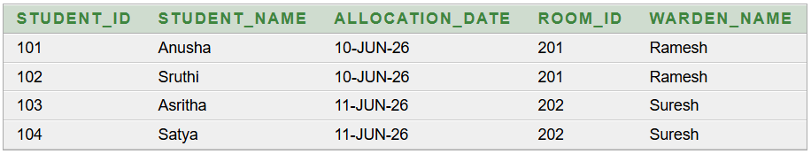

7.3 Second Normal Form (2NF)
In 2NF, partial dependencies on a composite key are removed. Student-specific attributes depend on Student_ID, room-specific attributes depend on Room_ID, and allocation-specific attributes depend on Allocation_ID. These dependencies lead to separate Student, Hostel, Room, Allocation, and Payment relations.
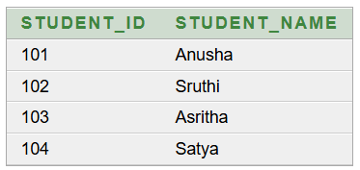
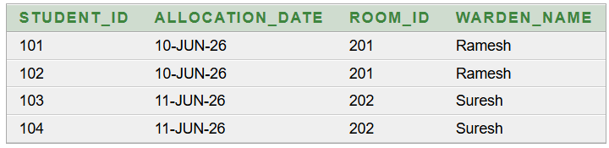

7.4 Third Normal Form (3NF)
In 3NF, transitive dependencies are removed. Hostel details are stored in the Hostel table rather than repeated in Student and Room. Room details are stored in the Room table rather than repeated in Allocation. Student and room information are referenced through Allocation, while Payment details are linked to Allocation through Payment. This structure reduces data redundancy and supports the objectives of 3NF.
Relation | Reason for Separation
Hostel | Stores hostel-specific details once.
Student | Stores student-specific details and references the hostel..
Room | Stores room-specific details and references the hostel.
Warden | Stores warden-specific details and references the hostel.
Allocation | Stores the student–room allocation relationship.
Payment | Stores payment details linked to an allocation.

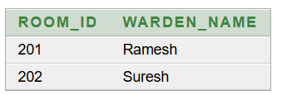
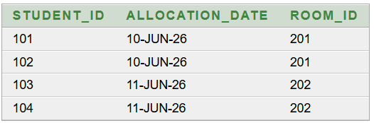

8. SQL IMPLEMENTATION

8.1 DDL – Data Definition Language
The following DDL is a documentation-ready implementation aligned with the supplied relational schema. Data types may be adjusted to the specific DBMS used by the student team.
CREATE TABLE HOSTELS11 (
Hostel_ID VARCHAR2(10) PRIMARY KEY,
Block_Name VARCHAR2(50) NOT NULL,
Location VARCHAR2(100)
);

CREATE TABLE STUDENTS11 (
Student_ID NUMBER PRIMARY KEY,
Student_Name VARCHAR2(100) NOT NULL,
Phone VARCHAR2(15),
Email VARCHAR2(100),
Department VARCHAR2(50),
Street VARCHAR2(100),
City VARCHAR2(50),
Pincode VARCHAR2(10),
Hostel_ID VARCHAR2(10),
FOREIGN KEY (Hostel_ID)
REFERENCES HOSTELS11(Hostel_ID)
);

CREATE TABLE WARDENS11 (
Warden_ID NUMBER PRIMARY KEY,
Warden_Name VARCHAR2(100) NOT NULL,
Phone VARCHAR2(15),
Email VARCHAR2(100)
);

CREATE TABLE ROOMS11 (
Room_ID NUMBER PRIMARY KEY,
Room_Type VARCHAR2(20),
Room_Status VARCHAR2(20),
Capacity NUMBER,
Warden_ID NUMBER,
FOREIGN KEY (Warden_ID)
REFERENCES WARDENS11(Warden_ID)
);

CREATE TABLE ALLOCATIONS11 (
Allocation_ID NUMBER PRIMARY KEY,
Allocation_Date DATE,
Student_ID NUMBER,
Room_ID NUMBER,
FOREIGN KEY (Student_ID)
REFERENCES STUDENTS11(Student_ID),
FOREIGN KEY (Room_ID)
REFERENCES ROOMS11(Room_ID)
);
CREATE TABLE PAYMENTS11 (
Payment_ID NUMBER PRIMARY KEY,
Student_ID NUMBER,
Payment_Date DATE,
Amount NUMBER(10,2),
Payment_Status VARCHAR2(20),
FOREIGN KEY (Student_ID)
REFERENCES STUDENTS11(Student_ID)
);

8.2 DML – Data Manipulation Language

INSERT INTO HOSTELS11 (Hostel_ID, Block_Name, Location)
VALUES ('H01', 'A Block', 'Surampalem');

INSERT INTO HOSTELS11 (Hostel_ID, Block_Name, Location)
VALUES ('H02', 'B Block', 'Surampalem');

INSERT INTO WARDENS11 (Warden_ID, Warden_Name, Phone, Email)
VALUES (501, 'Ramesh', '9876543210', 'ramesh@gmail.com');

INSERT INTO WARDENS11 (Warden_ID, Warden_Name, Phone, Email)
VALUES (502, 'Suresh', '9876543211', 'suresh@gmail.com');

INSERT INTO STUDENTS11
(Student_ID, Student_Name, Phone, Email, Department, Street, City, Pincode, Hostel_ID)
VALUES
(1001, 'Anusha', '9876501001', 'anusha@gmail.com', 'CSE', 'Main Road', 'Surampalem', '533437', 'H01');

INSERT INTO STUDENTS11
VALUES
(1002, 'Sravani', '9876501002', 'sravani@gmail.com', 'CSE', 'College Road', 'Surampalem', '533437', 'H01');

INSERT INTO ROOMS11
(Room_ID, Room_Type, Room_Status, Capacity, Warden_ID)
VALUES
(201, 'AC', 'Occupied', 3, 501);

INSERT INTO ROOMS11
VALUES
(203, 'Non-AC', 'Occupied', 3, 502);

INSERT INTO ALLOCATIONS11
(Allocation_ID, Allocation_Date, Student_ID, Room_ID)
VALUES
(3001, TO_DATE('01-AUG-26','DD-MON-RR'), 1001, 201);

INSERT INTO ALLOCATIONS11
VALUES
(3006, TO_DATE('01-AUG-26','DD-MON-RR'), 1006, 201);

INSERT INTO PAYMENTS11
(Payment_ID, Student_ID, Payment_Date, Amount, Payment_Status)
VALUES
(4001, 1001, TO_DATE('01-AUG-26','DD-MON-RR'), 50000, 'Paid');

INSERT INTO PAYMENTS11
VALUES
(4002, 1002, TO_DATE('01-AUG-26','DD-MON-RR'), 50000, 'Paid');

8.3 DQL – Data Query Language

-- 1. Display all students
SELECT *
FROM Student;

-- 2. Display students staying in a particular hostel
SELECT Student_ID, Student_Name, Email
FROM Student
WHERE Hostel_ID = 1;

-- 3. Display all rooms in room-number order
SELECT Room_ID, Hostel_ID, Room_Type, Capacity, Room_Status
FROM Room
ORDER BY Room_ID;

-- 4. Display students with their hostel details
SELECT s.Student_Name, h.Hostel_Name
FROM Student s
JOIN Hostel h ON s.Hostel_ID = h.Hostel_ID;

-- 5. Display students with their allocated room details
SELECT s.Student_Name, r.Room_ID, r.Room_Type, a.Allocation_Date
FROM Student s
JOIN Allocation a ON s.Student_ID = a.Student_ID
JOIN Room r ON a.Room_ID = r.Room_ID;

9. SQL QUERIES & SCREENSHOTS
The following query set is prepared to satisfy the documentation requirement for a 30–40 query SQL section. The examples cover selection, filtering, joins, aggregation, subqueries, updates, deletion, and reporting. Exact outputs depend on the records inserted in the final project database.
Q1. Display all departments
SELECT * FROM STUDENT11;
Output:
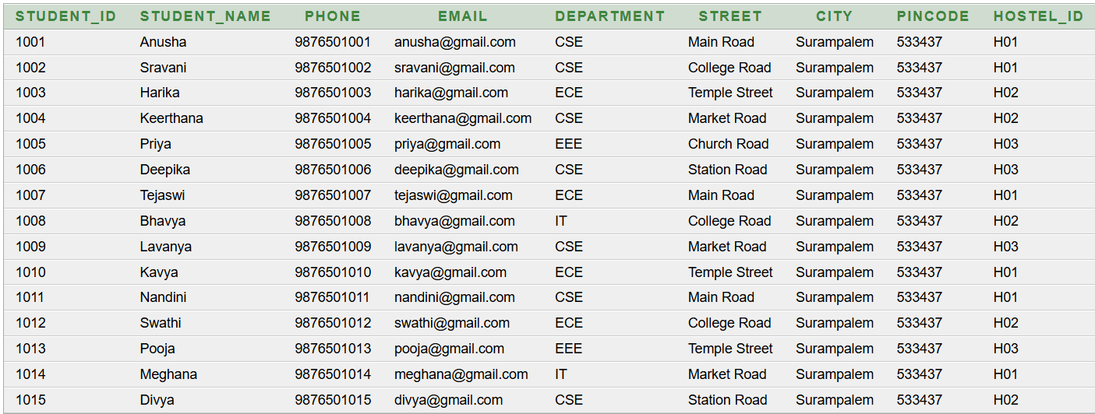
Q2. Display students belonging to CSE
SELECT Student_Name
FROM STUDENTS11
WHERE Department='CSE';
Output:
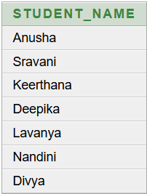
Q3. Write a query to display the student names along with their room numbers.
SELECT s.Student_Name, a.Room_ID
FROM STUDENTS11 s, ALLOCATIONS11 a
WHERE s.Student_ID=a.Student_ID;
Output:
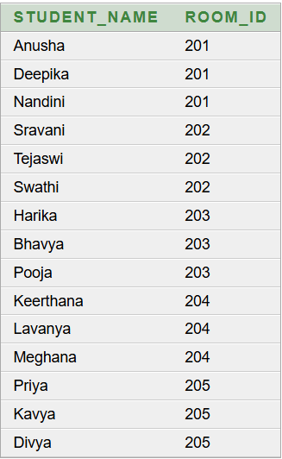
Q4. Write a query to display student names along with their payment status.
SELECT s.Student_Name, p.Payment_Status
FROM STUDENTS11 s, PAYMENTS11 p
WHERE s.Student_ID=p.Student_ID;

Output:
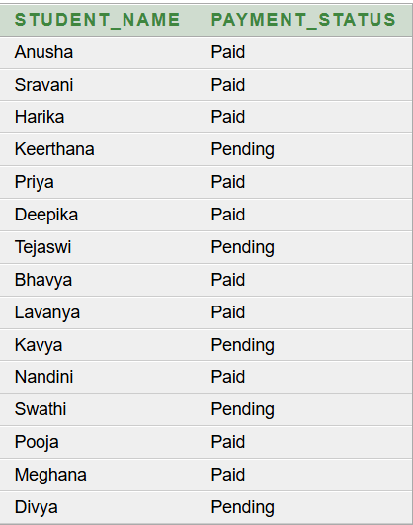

Q5. Write a query to display the details of AC rooms.
SELECT Room_ID, Room_Type, Room_Status, Capacity
FROM ROOMS11
WHERE Room_Type='AC';
Output:
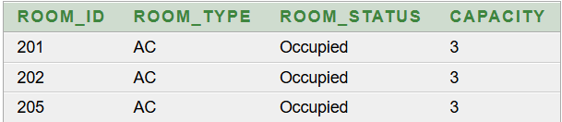

Q6. Write a query to find the names of students staying in hostel H01.
SELECT Student_Name
FROM STUDENTS11
WHERE Hostel_ID='H01';
Output:
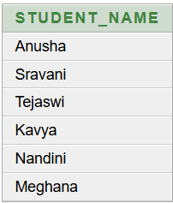

Q7. Write a query to display student names in ascending order.
SELECT Student_Name
FROM STUDENTS11
ORDER BY Student_Name;

Output:
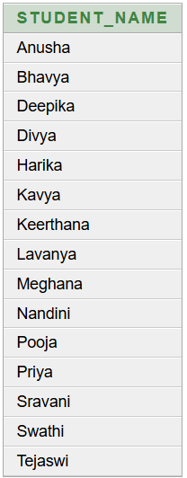
Q8. Write a query to find the names of students who are allocated to Room 201.
SELECT s.Student_Name
FROM STUDENTS11 s
WHERE s.Student_ID IN
(
SELECT a.Student_ID
FROM ALLOCATIONS11 a
WHERE a.Room_ID=201
);
Output:
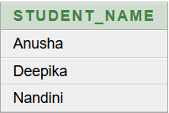

Q9 Write a query to find the names of students who are not allocated to Room 201.
SELECT s.Student_Name
FROM STUDENTS11 s
WHERE s.Student_ID NOT IN
(
SELECT a.Student_ID
FROM ALLOCATIONS11 a
WHERE a.Room_ID=201
);
Output:
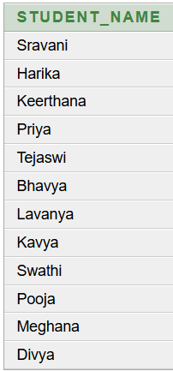
Q10. Write a query to find the names of students who are staying in AC rooms.
SELECT s.Student_Name
FROM STUDENTS11 s
WHERE s.Student_ID IN
(SELECT a.Student_ID
FROM ALLOCATIONS11 a
WHERE a.Room_ID IN
(SELECT r.Room_ID
FROM ROOMS11 r
WHERE r.Room_Type='AC' )
);
Output:
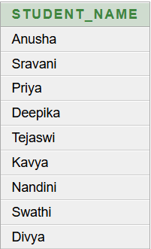

Q11. Write a query to find the student who paid the highest amount.
SELECT s.Student_Name, p.Amount
FROM STUDENTS11 s, PAYMENTS11 p
WHERE s.Student_ID=p.Student_ID
AND p.Amount>=ALL
(
SELECT p1.Amount
FROM PAYMENTS11 p1
);
Output:
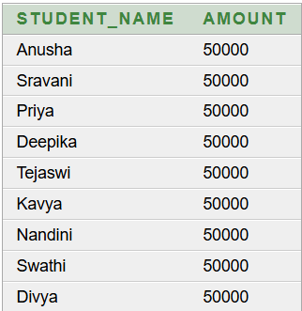

Q12. Write a query to find students who paid more than at least one student who paid ₹40,000.
SELECT s.Student_Name, p.Amount
FROM STUDENTS11 s, PAYMENTS11 p
WHERE s.Student_ID=p.Student_ID
AND p.Amount>ANY
( SELECT p1.Amount
FROM PAYMENTS11 p1
WHERE p1.Amount=40000);
Output:
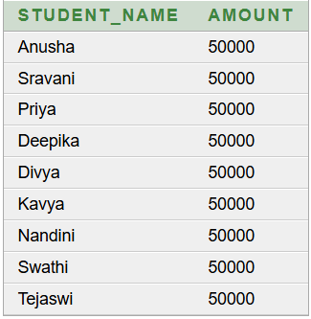

Q13. Write a query to find the names of students who have made a payment.
SELECT s.Student_Name
FROM STUDENTS11 s
WHERE EXISTS
(SELECT *
FROM PAYMENTS11 p
WHERE p.Student_ID=s.Student_ID);

Output:
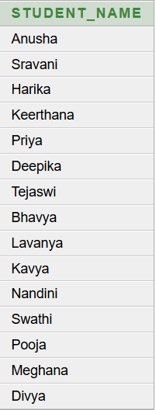

Q14. Write a query to find the average payment amount for each department.
SELECT s.Department, AVG(p.Amount)
FROM STUDENTS11 s, PAYMENTS11 p
WHERE s.Student_ID=p.Student_ID
GROUP BY s.Department;
Output:
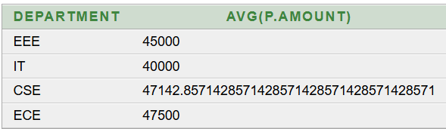

Q15. Write a query to find the rooms having at least 3 students.
SELECT a.Room_ID, COUNT(*)
FROM ALLOCATIONS11 a
GROUP BY a.Room_ID
HAVING COUNT(*)>=3;
Output:
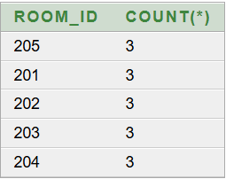

11. CONCLUSION
The Student Hostel Management System provides a structured relational database solution for managing student, hostel, room, allocation, warden, and payment information. The database uses primary keys, foreign keys, uniqueness rules, NOT NULL conditions, and CHECK constraints to maintain data integrity. The normalization process up to 3NF reduces data redundancy and update anomalies. The SQL implementation supports operations such as insertion, modification, retrieval, and payment-related reporting. Overall, the project provides a suitable DBMS-based solution for efficient hostel management and can be extended into a complete hostel administration system.

12. FUTURE ENHANCEMENTS
- Student registration and profile management.
- Room transfer management.
- Check-in and check-out tracking.
- Mess and meal management.
- Fee due and fine management.
- Complaint status tracking.
- Visitor entry management.
- Student attendance monitoring.
- Emergency contact management.
- Notifications and announcements.
- Search and report generation.
- Data privacy and security.
- Database backup and recovery.
- Historical record maintenance.

REFERENCES
1. Korth, H. F., Silberschatz, A., and Sudarshan, S., Database System Concepts, McGraw Hill.
2. Elmasri, R. and Navathe, S. B., Fundamentals of Database Systems, Pearson.
3. Silberschatz, A., Korth, H. F., and Sudarshan, S., Database System Concepts, 7th Edition, McGraw Hill.
4. Elmasri, R. and Navathe, S. B., Fundamentals of Database Systems, 7th Edition, Pearson.
5. Oracle Corporation, Oracle Database 10g Documentation, Oracle Corporation.
6. Oracle Corporation, Oracle Database SQL Reference, Oracle Corporation.
7. Oracle Corporation, Oracle Database Concepts, Oracle Corporation.
8. Ramakrishnan, R. and Gehrke, J., Database Management Systems, 3rd Edition, McGraw Hill.
9. Date, C. J., An Introduction to Database Systems, 8th Edition, Pearson.
10.Connolly, T. and Begg, C., Database Systems: A Practical Approach to Design, Implementation, and Management, Pearson.
11.PostgreSQL Global Development Group, PostgreSQL Documentation, PostgreSQL.
12.MySQL, MySQL 8.0 Reference Manual, Oracle Corporation.

